FirstStep Careers Site Plan

Austin Brackney

WDD 130

Overview

Purpose
FirstStep Careers is made to help users take their first steps in finding their first job or internship. The target audience are those who would be looking for guidance in finding a job or internship, people who just finished high school or are early in their higher education.

Audience
Students who just finished high school or are in College looking for employment/internships.

Branding

Website Logo
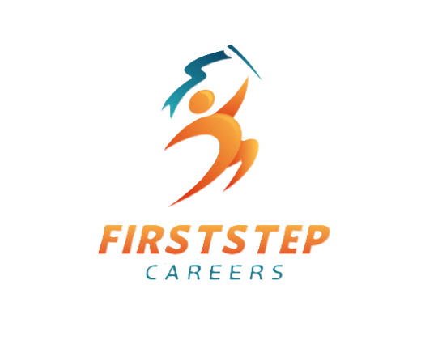

Style Guide

Color Palette
Primary | Secondary | Accent 1 | Accent 2
#DC602E | #15E0E0 | #D24F37 | #336984

Typography

Heading Font: Verdana, Geneva, Times New Roman

Paragraph Font: Helvetica, Times, Arial

Navigation
Home Resume Tips Job Search Interview Prep

Content

- Home Page (index.html)
  - Navigation
    - Home
    - Resume Tips
    - Job Search
    - Interview Prep
    - Button: Get Started
  - Hero Section
    - Heading: Start Your Career Journey Today
    - Text: Finding your first job or internship can feel overwhelming, but everyone starts somewhere. FirstStep Careers provides simple guidance to help students and beginners prepare resumes, search for opportunities, and succeed in interviews.
    - Button: Get Started
  - Section: What You'll Learn
    - Create a Resume
      - Learn how to write a simple resume even if you don’t have much experience yet.
    - Search for Opportunities
      - Discover where to find internships and entry-level jobs.
    - Prepare for Interviews
      - Get tips to answer common interview questions with confidence.
  - Section: Why Start Early?
    - Starting your career journey early helps you:
      - Build valuable experience
      - Develop professional skills
      - Grow your network
      - Discover career interests
- Resume Tips Page (resume.html)
  - Hero
    - Title: How to Write Your First Resume
    - Paragraph: A resume is a short document that shows employers your skills, education, and experience. Even if you haven’t had a job before, you can still create a strong resume.
  - Section: What to Include
    - 1. Contact Information
      - Include:
        - Full name
        - Email address
        - Phone number
        - LinkedIn (optional)
    - 2. Education
      - List:
        - School name
        - Degree or program
        - Expected graduation year
    - 3. Skills
      - Examples:
        - Communication
        - Teamwork
        - Time management
        - Microsoft Office
        - Basic programming
    - 4. Experience
      - If you haven't had a job yet, include:
        - School projects
        - Volunteer work
        - Clubs or organizations
        - Leadership roles
  - Quick Resume Tips
    - Keep it one page
    - Use clear headings
    - Avoid spelling mistakes
    - Use simple formatting
- Job Search Guide (jobs.html)
  - Hero
    - Title: Finding Your First Job or Internship
    - Title paragraph: There are many places to find job and internship opportunities. Start by exploring online job boards and networking with people you know.
  - Section: Where to Look
    - Online Job Boards:
      - LinkedIn
      - Indeed
      - Handshake (for students)
    - Company Websites:
      - Find companies you're interested in
      - Visit their website
      - Look for the Careers section
    - Career Centers (if you are a student) can help you:
      - Review resumes
      - Practice interviews
      - Find internships
  - Section: Tips for Applying
    - Tailor your resume to each job
    - Follow all application instructions
    - Apply early
    - Keep track of applications
- Interview Preparation Page (interview.html)
  - Hero
    - Title: Preparing for Your First Interview
    - Paragraph: Interviews allow employers to learn about you and your skills. Preparation will help you feel more confident.
  - Common Interview Questions
    - Tell me about yourself
      - Tip: Talk briefly about your education, interests, and career goals.
    - Why do you want this job?
      - Tip: Explain what interests you about the company and role.
    - What are your strengths?
      - Examples:
        - Good communication
        - Strong work ethic
        - Problem-solving
  - Interview Tips
    - Research the company
    - Practice answering questions
    - Dress professionally
    - Arrive early
    - Bring a copy of your resume
  - After the Interview
    - Send a short thank-you email to show appreciation for the opportunity.
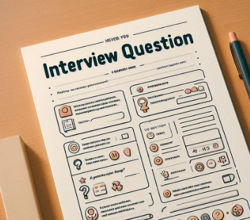



    - Example: Thank you for taking the time to speak with me today. I enjoyed learning more about the role and your team. I look forward to hearing from you.




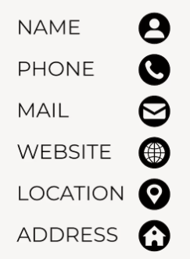





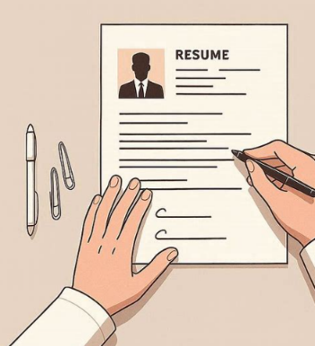

Wireframes

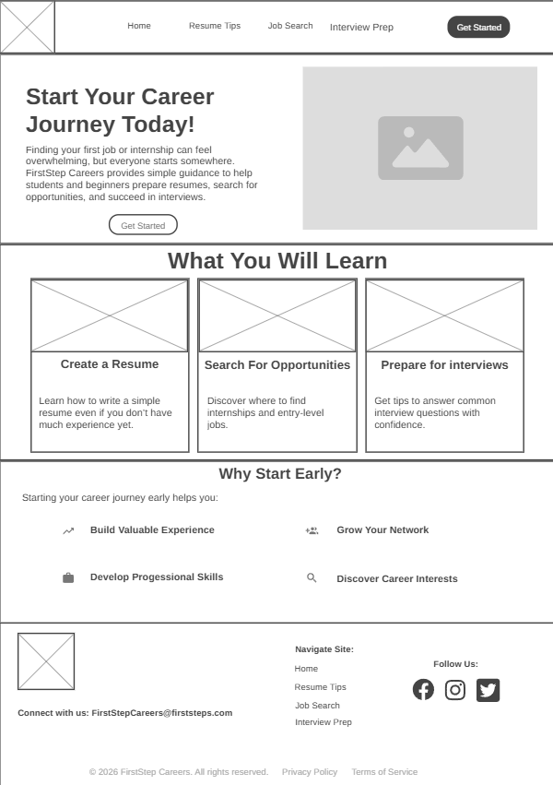
Home

